COVID 19 PATIENTS DIAGNOSIS
SQL QUERY
- Number of Patients
SELECT COUNT(*) AS TOTAL_NO_OF_PATIENTS
FROM covid19_Patient_Diagnosis;


- Number of Covid 19 Positive/Negative Patients
SELECT covid_result, COUNT(*) AS Positive_and_Negative_Count
FROM covid19_Patient_Diagnosis
GROUP BY covid_result;
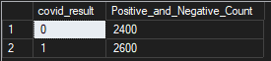

- Number of Covid 19 Positive Cases by Comordibity
SELECT
comorbidity,
COUNT(*) AS positive_cases
FROM covid19_Patient_Diagnosis
WHERE covid_result = '1'
GROUP BY comorbidity;
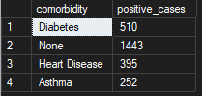

- Number of Covid 19 Negative Cases by Comordibity
SELECT comorbidity, COUNT(*) AS Negative_case
FROM covid19_Patient_Diagnosis
WHERE covid_result = '0'
GROUP BY comorbidity;
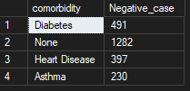
- Positivity Rate
SELECT
ROUND(
100.0 * SUM(CASE WHEN covid_result = '1' THEN 1 ELSE 0 END) / COUNT(*),
2) AS positivity_rate,
ROUND(
100.0 * SUM(CASE WHEN covid_result = '0' THEN 1 ELSE 0 END) / COUNT(*),
2) AS negativity_rate
FROM covid19_Patient_Diagnosis;


- Covid 19 cases by Gender
SELECT gender, COUNT(*) AS positive_cases
FROM covid19_Patient_Diagnosis
WHERE covid_result = '1'
GROUP BY gender;
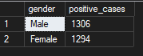

- Covid 19 Cases by Age Group
SELECT
CASE
WHEN age < 20 THEN '0-19'
WHEN age BETWEEN 20 AND 39 THEN '20-39'
WHEN age BETWEEN 40 AND 59 THEN '40-59'
ELSE '60+'
END AS age_group,
COUNT(*) AS positive_cases
FROM covid19_Patient_Diagnosis
WHERE covid_result = '1'
GROUP BY
CASE
WHEN age < 20 THEN '0-19'
WHEN age BETWEEN 20 AND 39 THEN '20-39'
WHEN age BETWEEN 40 AND 59 THEN '40-59'
ELSE '60+'
END
ORDER BY positive_cases DESC;
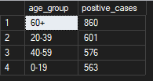

- Symptoms Strongly Associated with COVID 19
SELECT
'Fever' AS symptom, COUNT(*) AS count_positive
FROM covid19_Patient_Diagnosis
WHERE fever = '1' AND covid_result = '1'
UNION ALL
SELECT 'Dry Cough', COUNT(*)
FROM covid19_Patient_Diagnosis
WHERE dry_cough = '1' AND covid_result = '1'
UNION ALL
SELECT 'Loss of Smell', COUNT(*)
FROM covid19_Patient_Diagnosis
WHERE loss_of_smell = '1' AND covid_result = '1'
UNION ALL
SELECT 'Soar Throat', COUNT(*)
FROM covid19_Patient_Diagnosis
WHERE dry_cough = '1' AND covid_result = '1'
UNION ALL
SELECT 'Fatigue', COUNT(*)
FROM covid19_Patient_Diagnosis
WHERE fatigue = '1' AND covid_result = '1'
UNION ALL
SELECT 'Headache', COUNT(*)
FROM covid19_Patient_Diagnosis
WHERE headache = '1' AND covid_result = '1'
UNION ALL
SELECT 'Shortness of Breath', COUNT(*)
FROM covid19_Patient_Diagnosis
WHERE shortness_of_breath = '1' AND covid_result = '1'
UNION ALL
SELECT 'Loss of Smell', COUNT(*)
FROM covid19_Patient_Diagnosis
WHERE loss_of_smell = '1' AND covid_result = '1'
UNION ALL
SELECT 'Loss of Taste', COUNT(*)
FROM covid19_Patient_Diagnosis
WHERE loss_of_taste = '1' AND covid_result = '1';
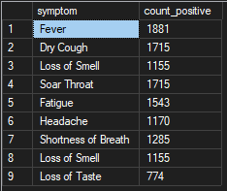

- Oxygen Level Analysis
SELECT covid_result, AVG(oxygen_level)
FROM covid19_Patient_Diagnosis
GROUP BY covid_result;
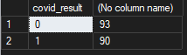

- Travel & Contact Risk
SELECT
travel_history,
contact_with_patient,
COUNT(*) AS positive_cases
FROM covid19_Patient_Diagnosis
WHERE covid_result = '1'
GROUP BY travel_history, contact_with_patient;
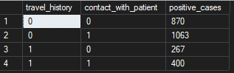

Note: 0 represents Covid Negative while 1 represents Covid Positive

